**Transform**

The transform CSS property lets you rotate, scale, skew, or translate an element. It modifies the coordinate space of the CSS visual formatting model.

If the property has a value different than none, a stacking context will be created. In that case, the element will act as a containing block for any position: fixed; or position: absolute; elements that it contains.

Syntax

CSS

/* Keyword values */

transform: none;

/* Function values */

transform: matrix(1, 2, 3, 4, 5, 6);

transform: matrix3d(1, 0, 0, 0, 0, 1, 0, 0, 0, 0, 1, 0, 0, 0, 0, 1);

transform: perspective(17px);

transform: rotate(0.5turn);

transform: rotate3d(1, 2, 3, 10deg);

transform: rotateX(10deg);

transform: rotateY(10deg);

transform: rotateZ(10deg);

transform: translate(12px, 50%);

transform: translate3d(12px, 50%, 3em);

transform: translateX(2em);

transform: translateY(3in);

transform: translateZ(2px);

transform: scale(2, 0.5);

transform: scale3d(2.5, 1.2, 0.3);

transform: scaleX(2);

transform: scaleY(0.5);

transform: scaleZ(0.3);

transform: skew(30deg, 20deg);

transform: skewX(30deg);

transform: skewY(1.07rad);

/* Multiple function values */

transform: translateX(10px) rotate(10deg) translateY(5px);

transform: perspective(500px) translate(10px, 0, 20px) rotateY(3deg);

The transform property may be specified as either the keyword value none or as one or more <transform-function> values.

If perspective() is one of multiple function values, it must be listed first.

**Values**

<transform-function>

One or more of the CSS transform functions to be applied. The transform functions are multiplied in order from left to right, meaning that composite transforms are effectively applied in order from right to left.

none

Specifies that no transform should be applied.

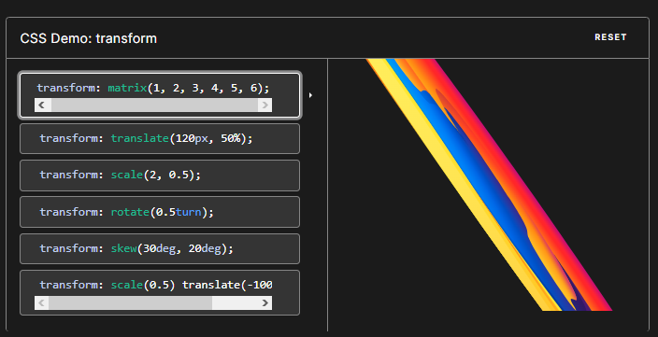

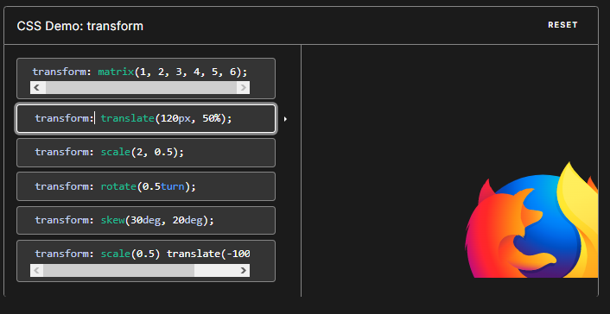

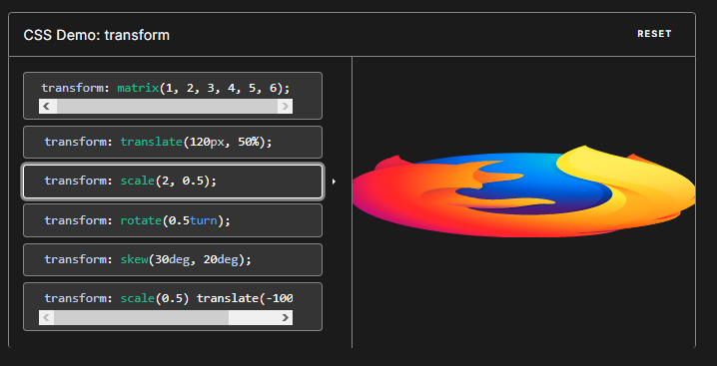

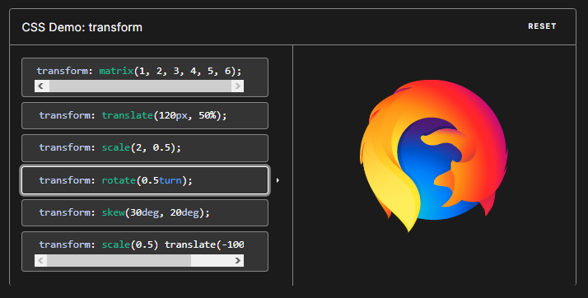

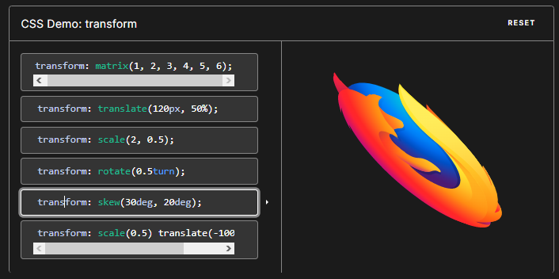

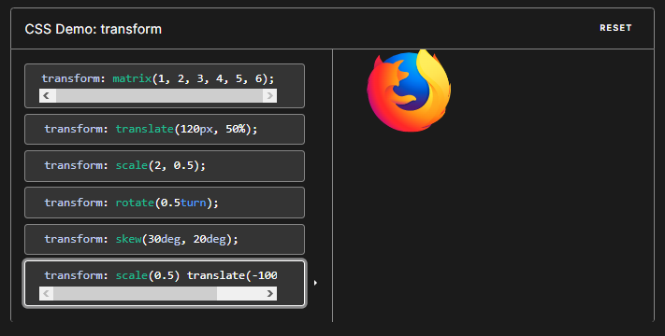

transform: scale(0.5) translate(-100%, -100%);

**Examples**

Translating and rotating an element

HTML

<div>Transformed element</div>

CSS

div {

border: solid red;

transform: translate(30px, 20px) rotate(20deg);

width: 140px;

height: 60px;

}

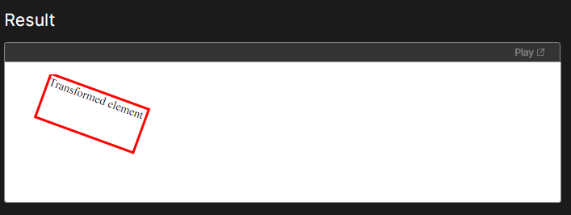

Examples

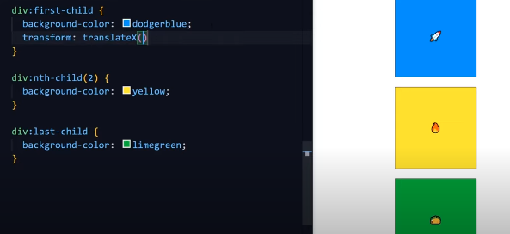

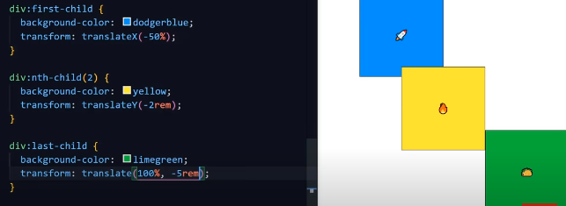

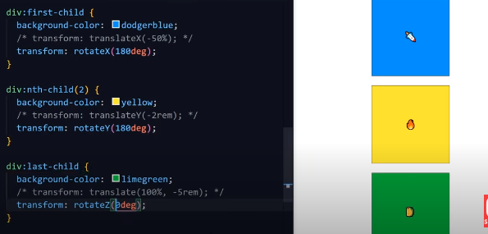

rotatez is same as default rotate

